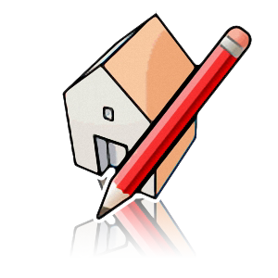

What is it?
Google SketchUp is modelling software that empowers students to be 3D designers. SketchUp is a great tool for constructing 3D models of buildings, trees, cars, and anything students can imagine. You can use it as a stand-alone tool, or in conjunction with Google Earth and the 3D Warehouse.
Why use it?
Students can use SketchUp to:
• Visualize geometry and other mathematical concepts.
• Create model buildings and learn about architecture.
• Design full-scale 3D environments.
• Easily share designs with others via the Web.
Teachers can use SketchUp to:
• Engage students using their knowledge of their bodies and the 3D world around them.
• Recreate historical settings.
• Illustrate theoretical concepts (such as chemical reactions).
Symbol | Tool | Notes
 | Select | Click on an object to select it. Drag over a group of objects to select them simultaneously.
 | Line | Draw straight lines through virtual space.
 | Rectangle | Draw, well, rectangles.
 | Circle | Actually draws 24-sided polygons. You can alter this. See further ahead.
 | Push/pull | ‘Drags’ a 2D shape into a 3D shape. Can create solids or voids.
 | Paint bucket | Applies colours or textures to surfaces.
 | Orbit | ‘Flies’ you around the scene.
 | Move/copy | Move components of your objects. Experiment!

The Basics
To begin you will need to select a template.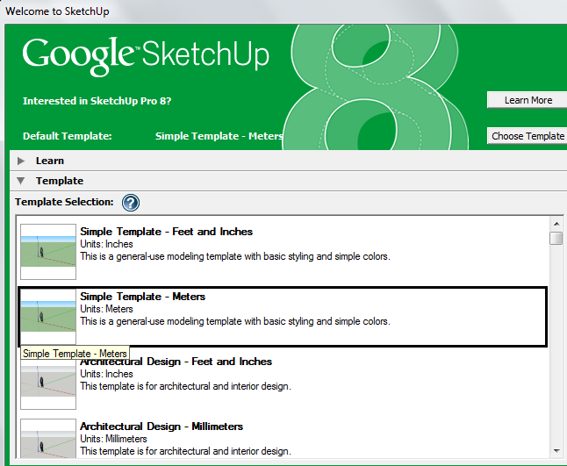
And click .
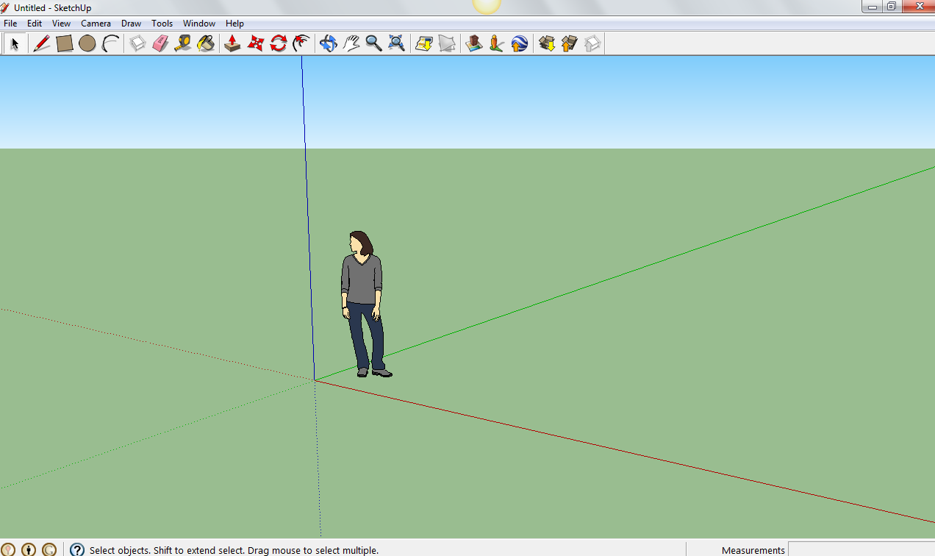
SketchUp is 3D. A key tool is the Orbit tool as it allows you to move around and orbit around the model.
The zoom tool also allow you to zoom in on key areas.
The pan tool allows you to move up and down, and side to side.
Click on the person to select.
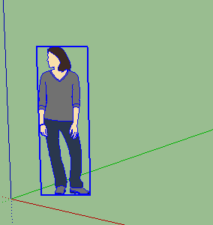
Then you can delete.
Use the Rectangle or Circle or tool to draw shapes.
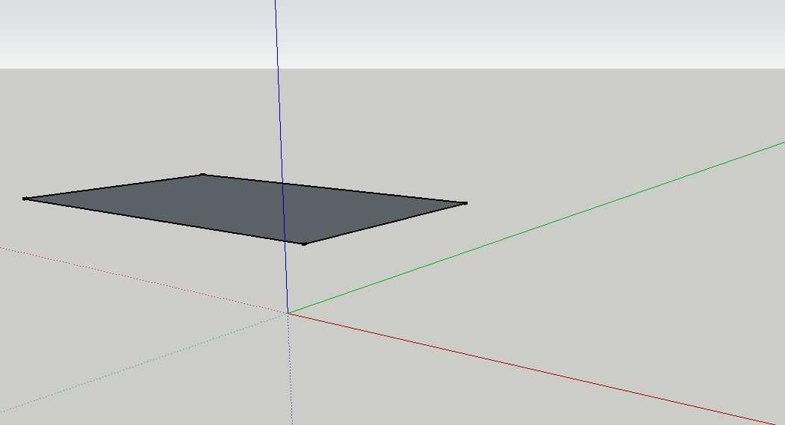.

Use the Push/pull tool to drags’ a 2D shape into a 3D shape. This creates solids or voids.
To be accurate you start the Push/pull tool and then type in a value(20cm) for it and select enter.
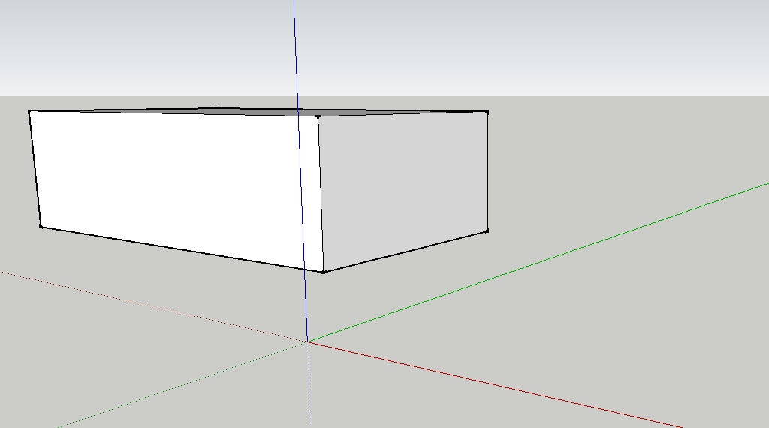
You can use the move tool to create slanted edges.
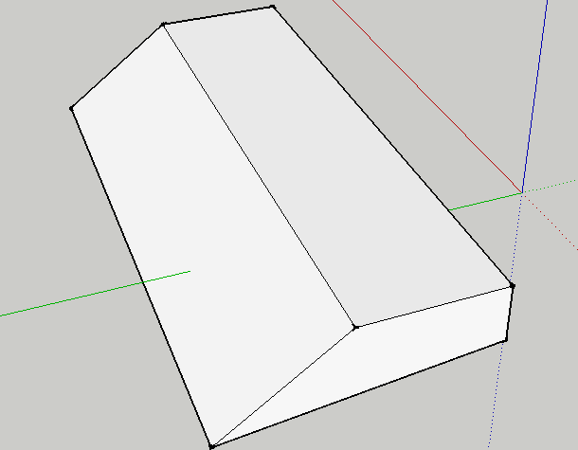

Drawing Shapes
Everything you create in SketchUp is an edge or a surface and interestingly a combination of both. Edges can exist on their own- surfaces cannot.

4 basic rules to drawing edges successfully
- Shapes need to be closed- they need to be coplanar. When drawing edges you must create a full loop of edges to create a closed surface.
They need to be coplanar- which is on the same plane- you can see this when you orbit. The top is on the same plane the bottom surface is not. The coloured axis gives you a guide for planes.
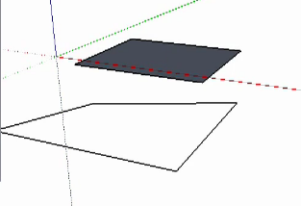.
- Watch the axis direction and use the line of inferring to line up edges.
Drawing edges will snap to the Red, Green or Blue axis.
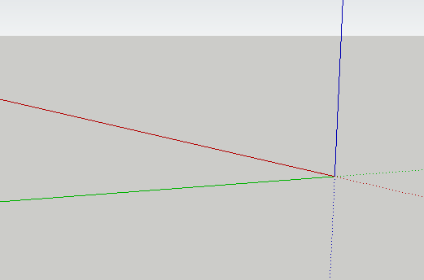
The key to using the axis directions is called inferring. This will keep you line up your axis by select the point you want to line up with so it gives you a guiding line.
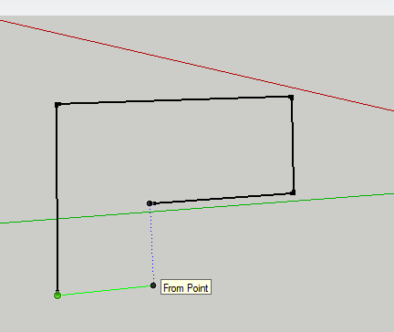
- Learn and use different inference points. Every time you draw an edge you will see a green point which indicates it is an end point. Sketch Up snaps to these points to draw accurately and effectively.
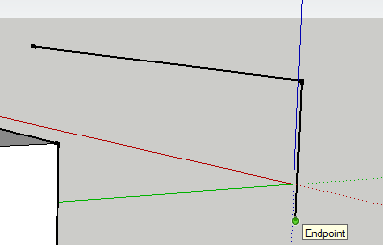
The middle of an end is shown by a cyan colour dot. 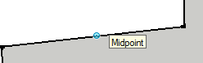
The other parts of an edge is shown by a red colour dot
Where two edges cross is shown by a black dot.
- Always draw to and from edges- don’t draw across another edge.
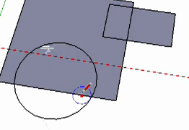

Filling a shape:
Use the Paint bucket tool to fill a shape- there are many options to choose from.
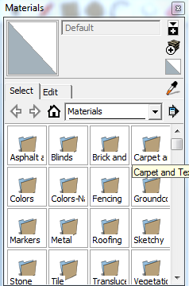

Google Warehouse
Google Warehouse allows you to download models and upload your creations.
http://sketchup.google.com/3dwarehouse/search?scoring=d
You can go to the file menu and select 3D warehouse and Get Model.
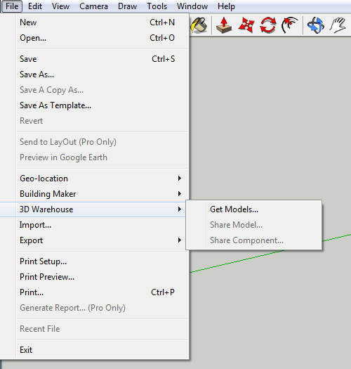
Search and select the model you would like to download:
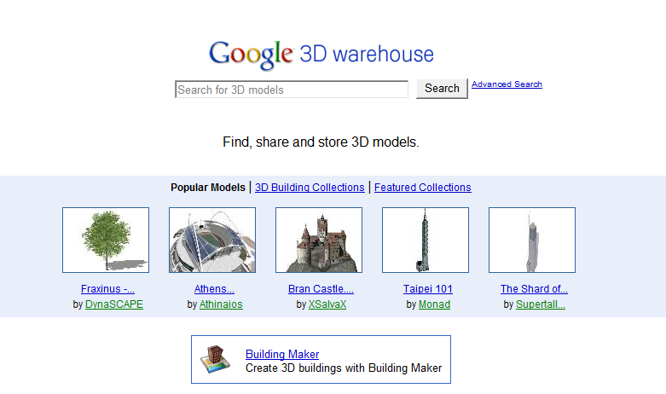
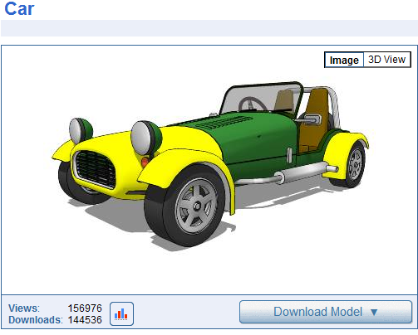
Click on the button.
Select Yes to download directly to your Sketch Up page.
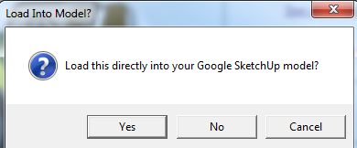
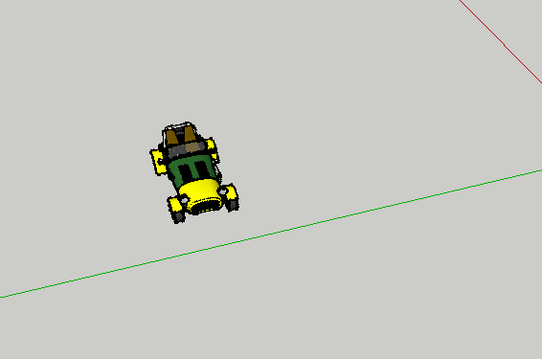
Now you can adjust or continue to build your model.

More Resources on SketchUp
- You Tube Tutorial http://www.youtube.com/watch?v=xqcL-xPC-Ys&feature=player_embedded#!

- Atomic Learning Tutorials http://www.atomiclearning.com/au/sketchup7
- SketchUp in Education - The official page with a gallery and case studies: http://www.google.com/sketchup/customers/education.html
- A SketchUp in Education Presentation with Student Samples http://tinyurl.com/5bjonz
- More student examples - created by 6th graders! http://tinyurl.com/4okvmv
- http://sketchupdate.blogspot.com.au/search/label/Education
http://sitescontent.google.com/google-sketchup-for-educators/Home

Ideas for How to Use SketchUp in Your Classroom

Build a 3D model of your school.

Use SketchUp to visualize the geometry concepts you are teaching.

Create a 3D model of a landmark and then incorporate those models into Google Earth.

Have students build a model of their houses, and geo-locate them in Google Earth.

When studying architecture of the past, create a 3D model of an ancient pyramid.

Students develop, model, build and present their design.

Starting with a real world object (or paper model), students learn how to a build 3D computer model replica.

Students participate in a project to recreate an important historical location (example: ancient Aztec city).

Students match 2D surface areas to 3D objects for various geometric shapes to build intuitive understanding of surface area.

Newtons laws and friction are taught by students who run mini-experiments using ramps with varied slopes.

Intuition about various key components in Biology and Chemistry is strengthened by building and comparing scaled models of the components.

Packaging design principles are taught by running through a package design process

An intuitive understanding of the principles of Geography and Geology are built by developing physical models of them.

Some Student Examples:
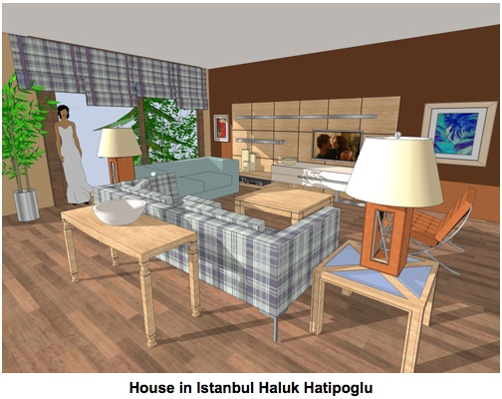  A Living scene | 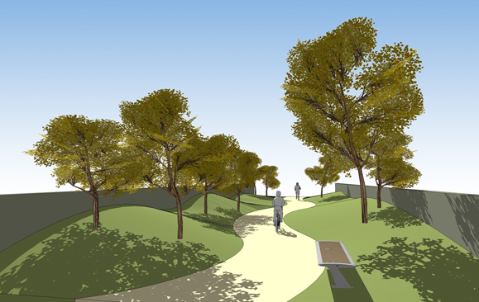  Design for a park
New building | 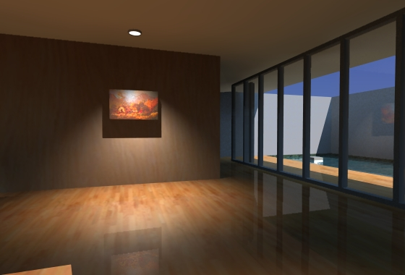  Display for Artwork
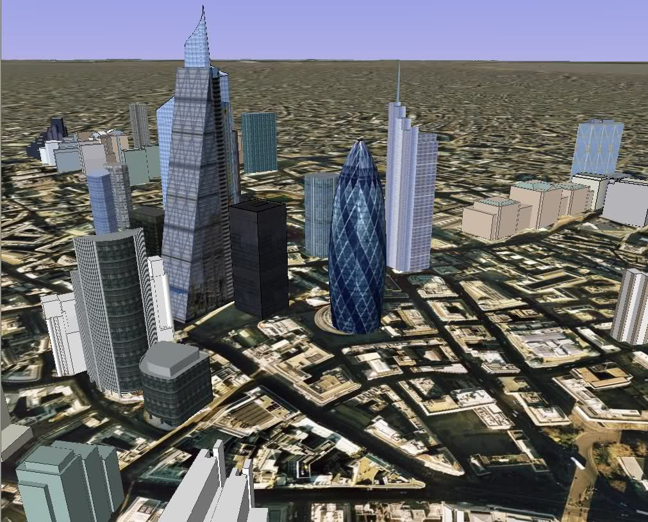  City Scene | 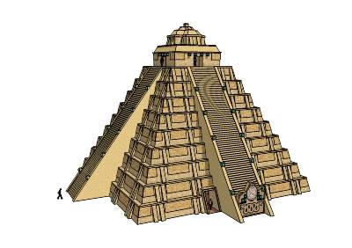  Pyramid
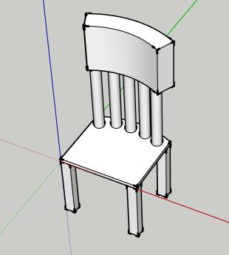  A model for chair | 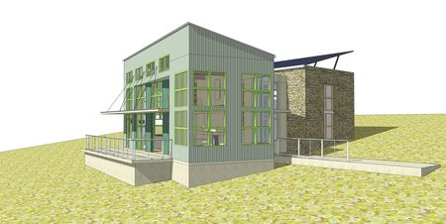  New House Design
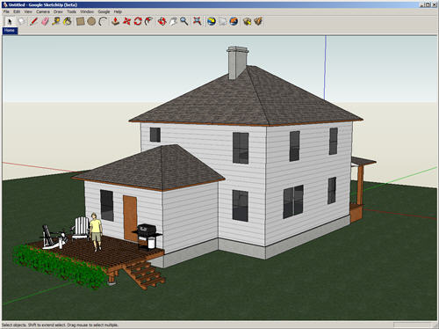  New House Design | 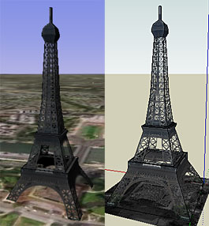  Replicate a landmark
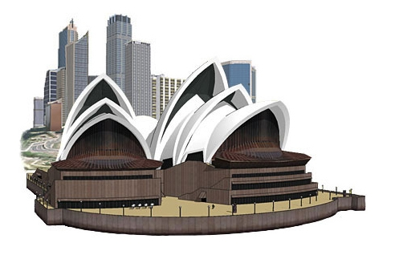  A landmark model | 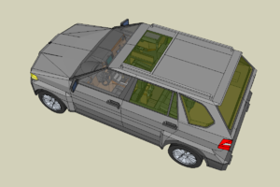  A car

